Journal Correspondence History

- Evizal Abdul Kadir, Sri Listia Rosa, Abdul Syukur, Mahmod Othman, and Hanita Daud Judul: “Forest fire spreading and carbon concentration identification in tropical region Indonesia” Dipublikasi di Journal Alexandria Engineering Journal, ISSN: 1110-0168 Online link: https://www.sciencedirect.com/science/article/pii/S1110016821004191

- Submission
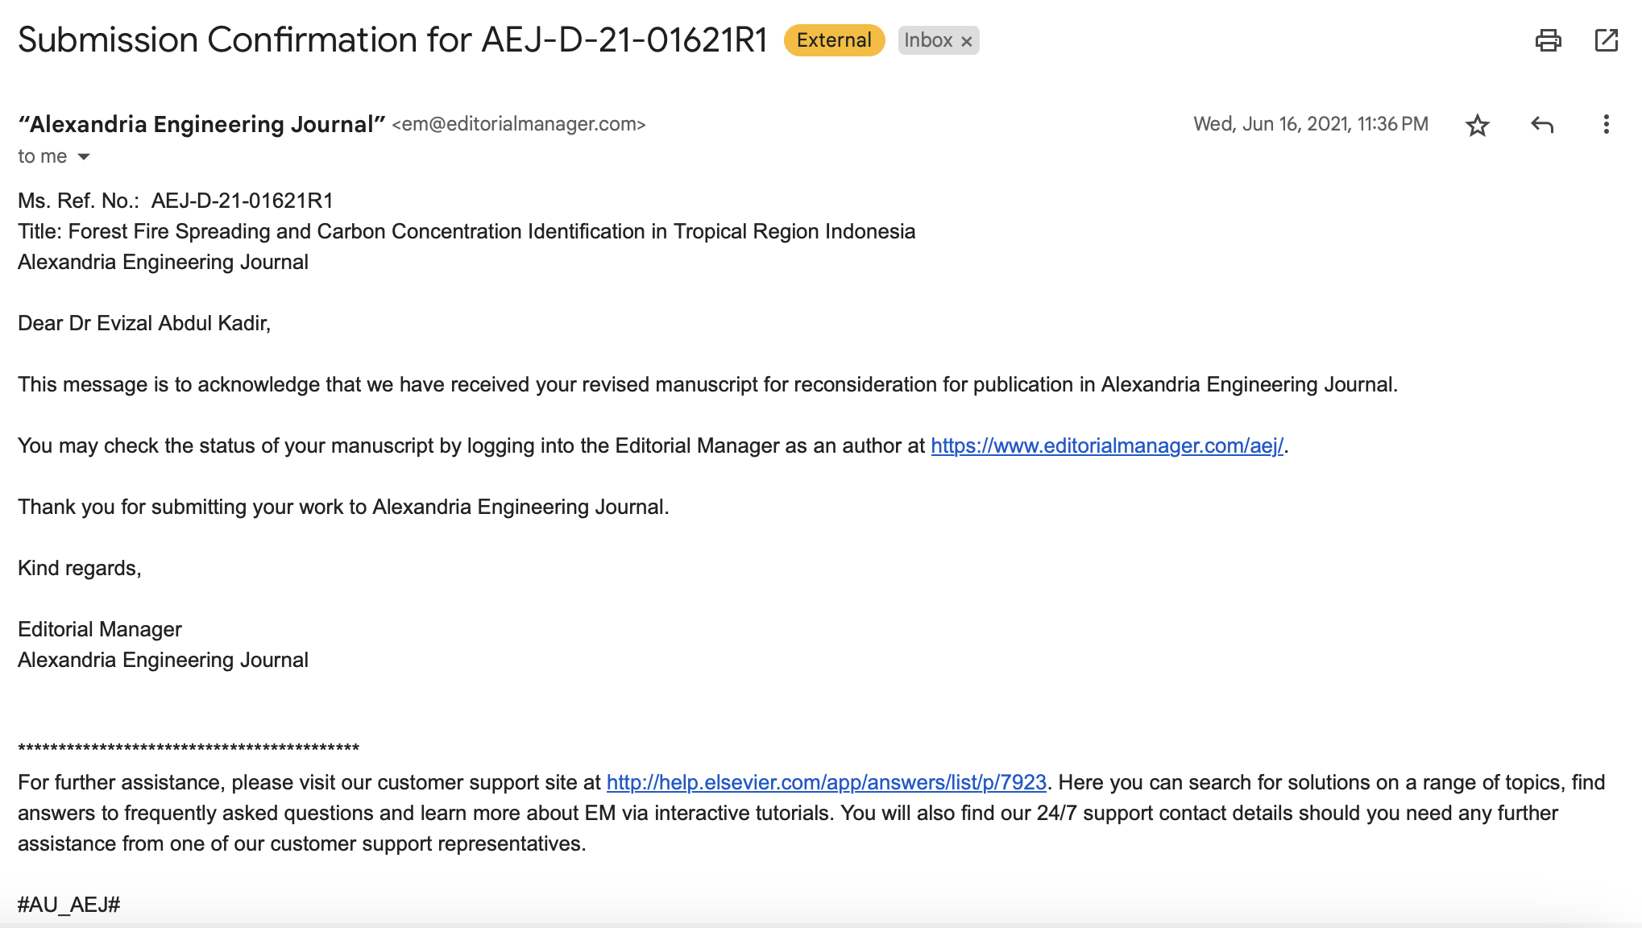

- Revision request

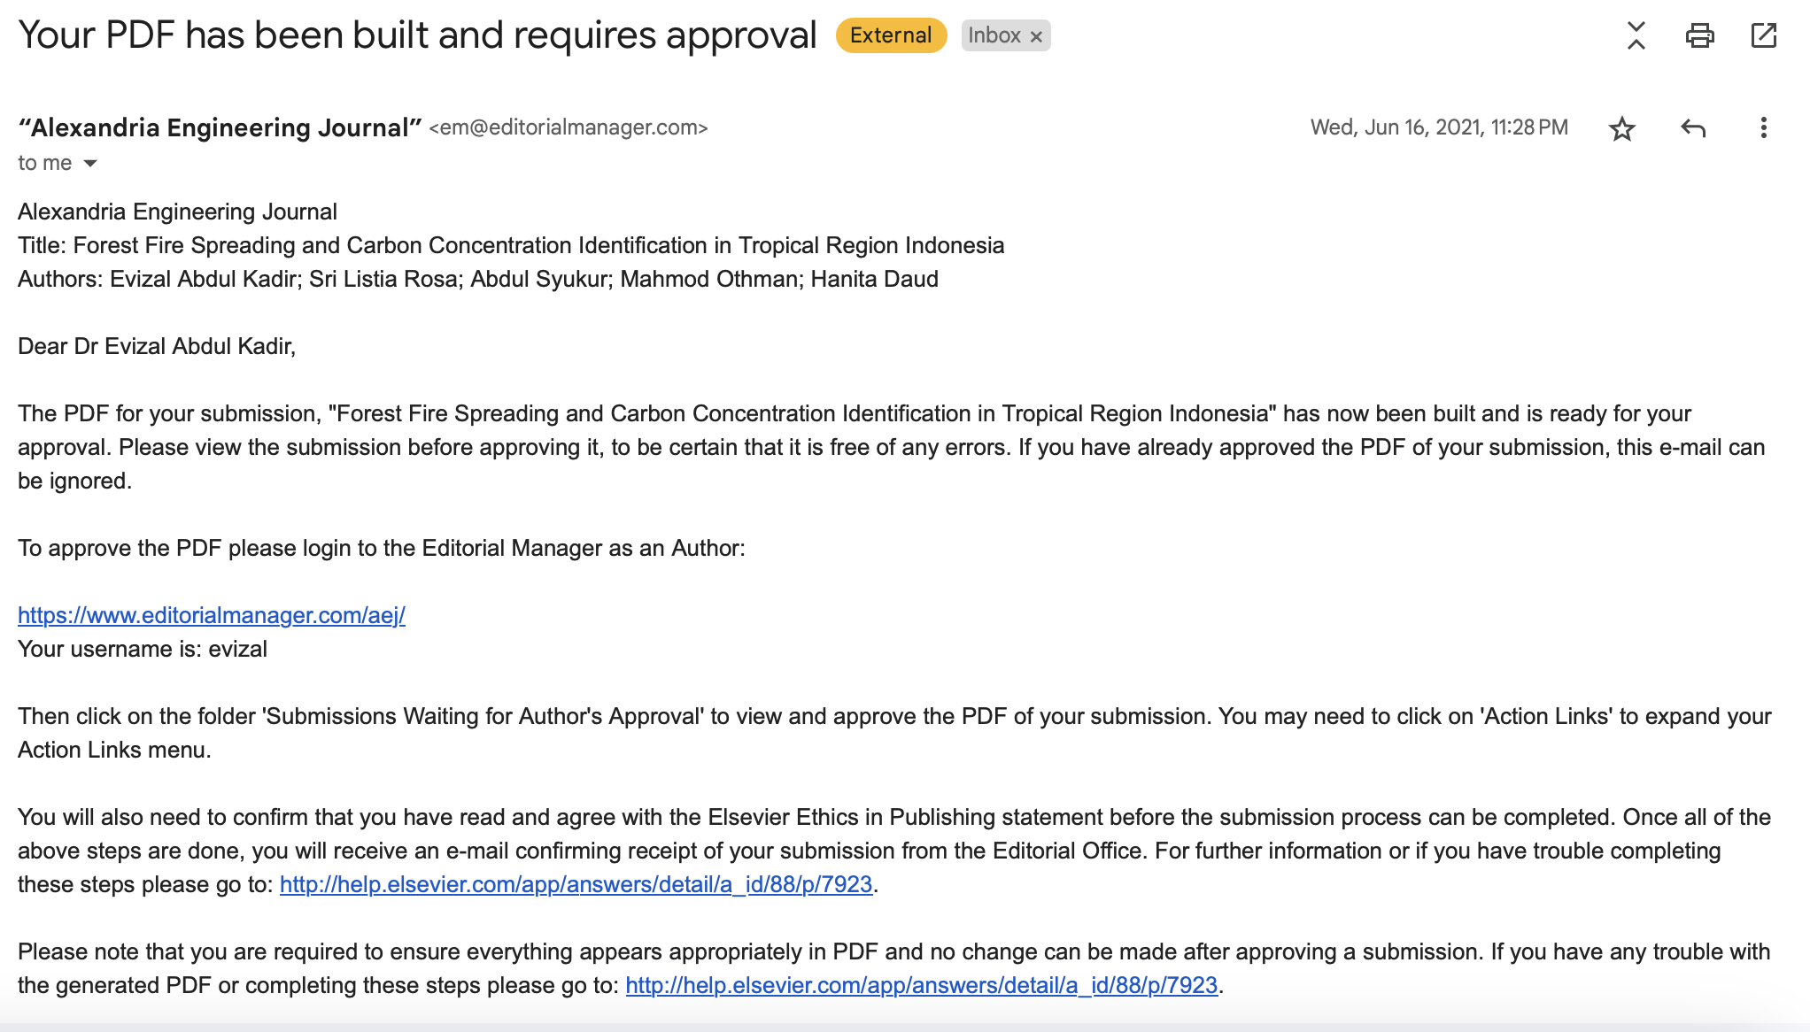

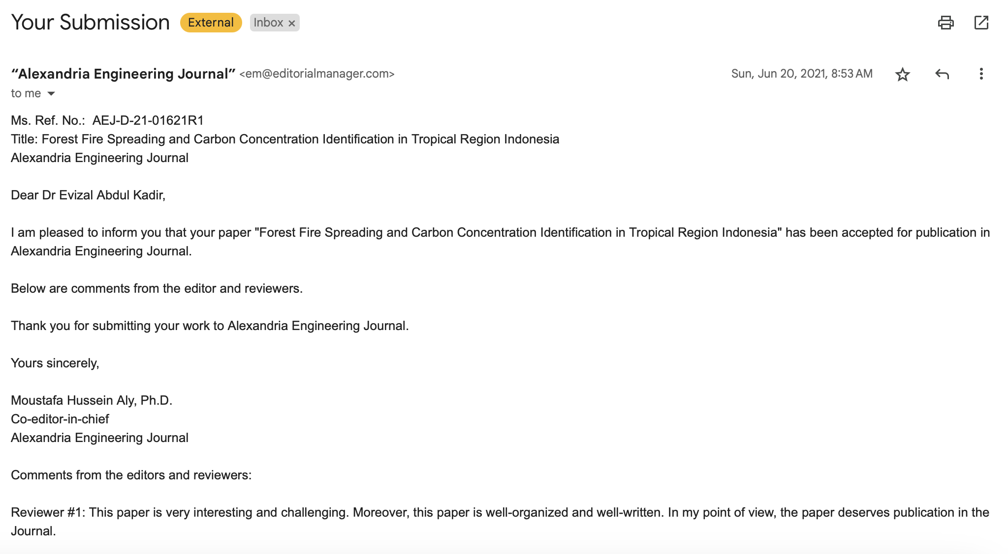

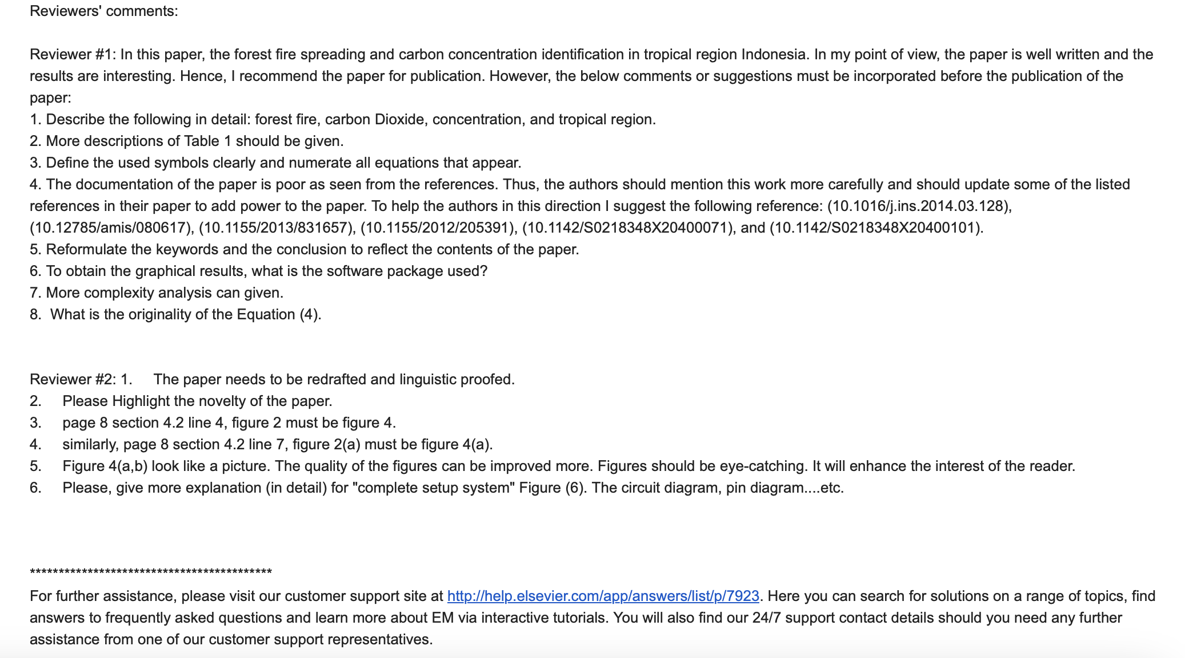

- Acceptance notification

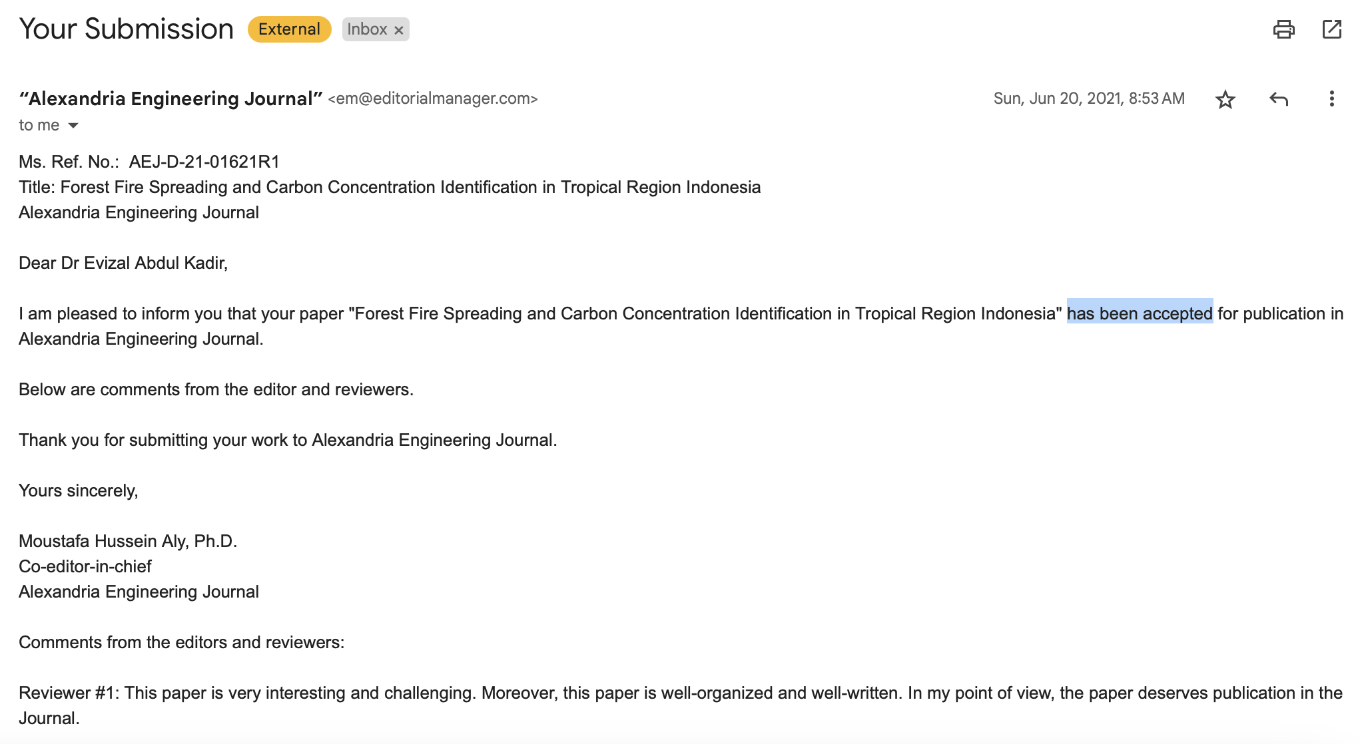

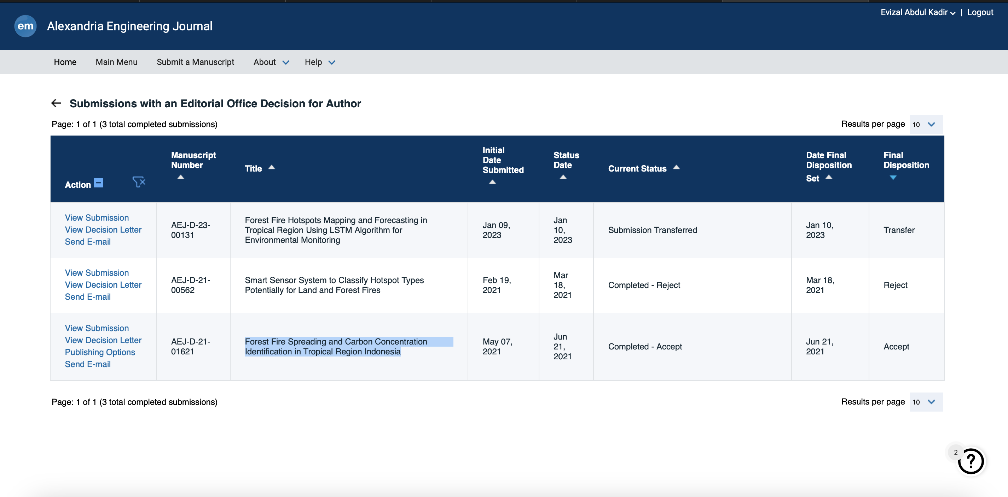

- Publish notification

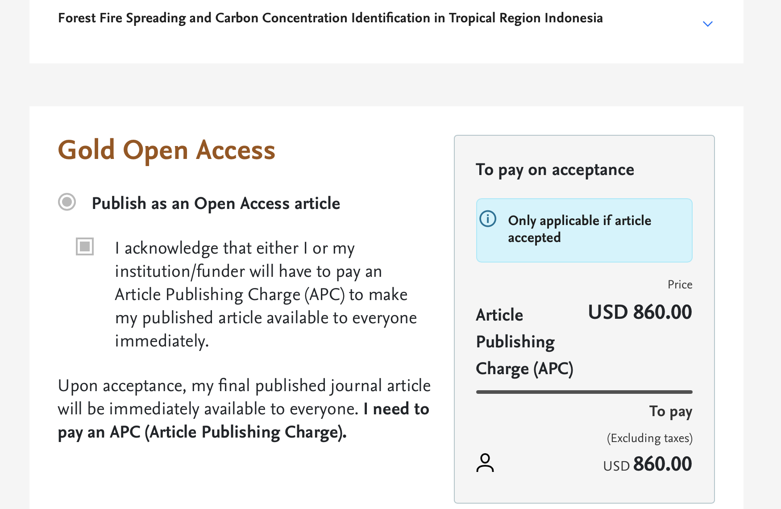

- Evizal Abdul Kadir, Hsiang Tsung Kung, Amal Abdullah AlMansour, Hitoshi Irie, Sri Listia Rosa, Shukor Sanim Mohd Fauzi, Judul: “Wildfire Hotspots Forecasting and Mapping for Environmental Monitoring Based on the Long Short-Term Memory Networks Deep Learning Algorithm” Dipublikasi pada Jurnal Environments” Vol 10, No.7 Tahun 2023, Hal. 474-477. ISSN: 1993-5250. Online link: https://www.mdpi.com/2076-3298/10/7/124

- Submission

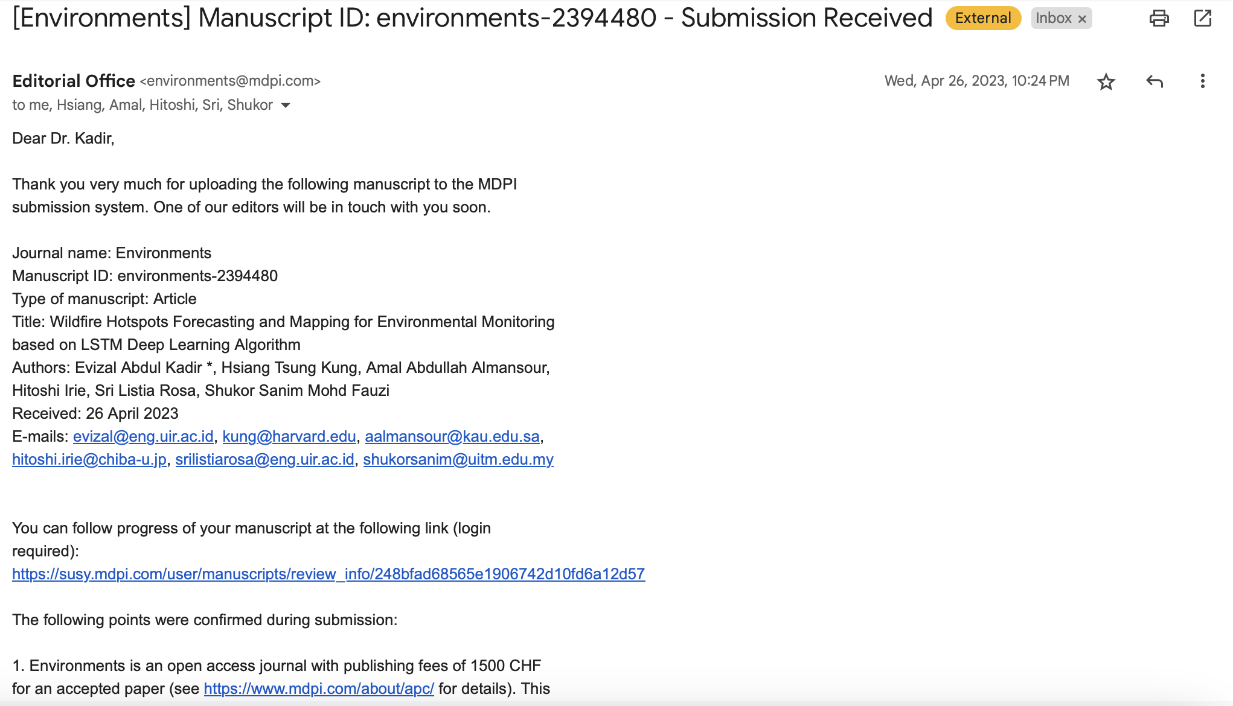

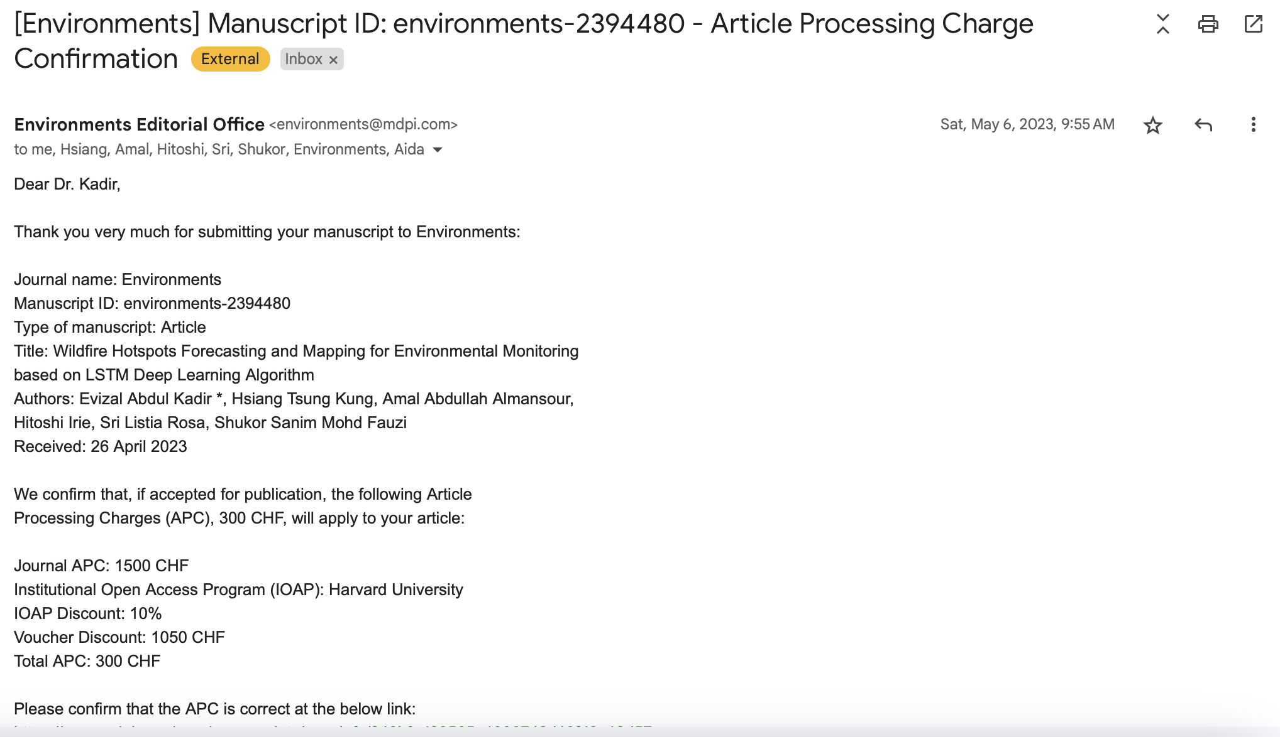

- Revision request

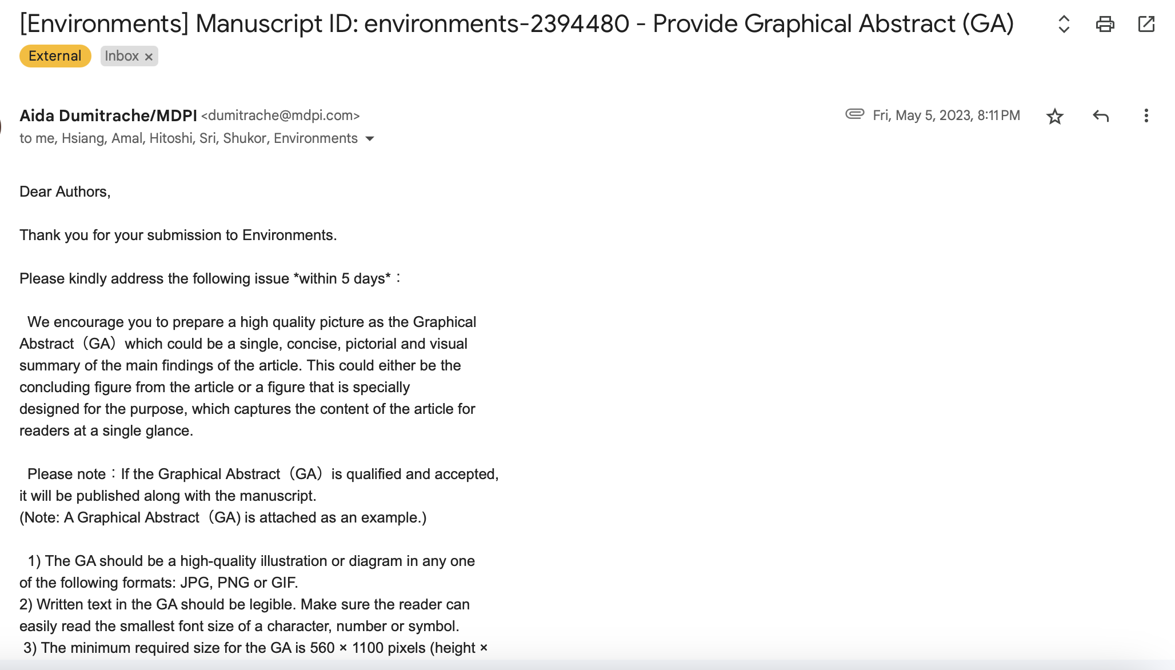

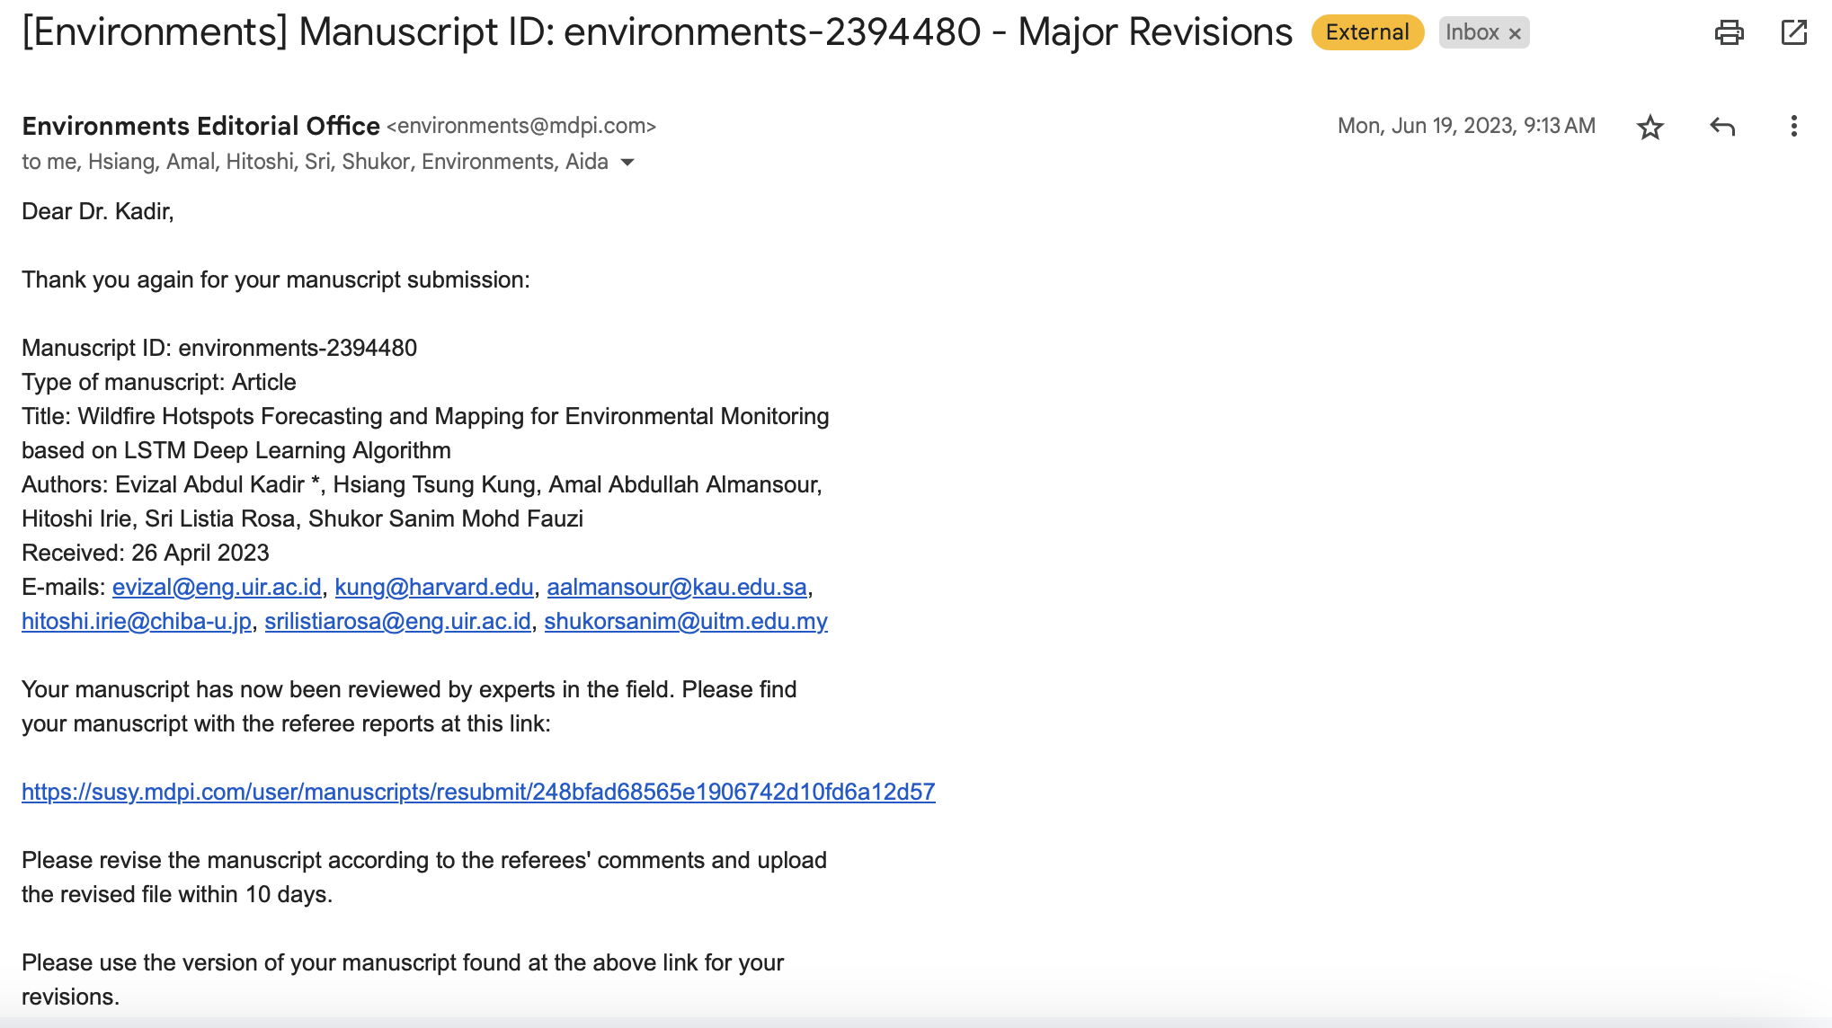

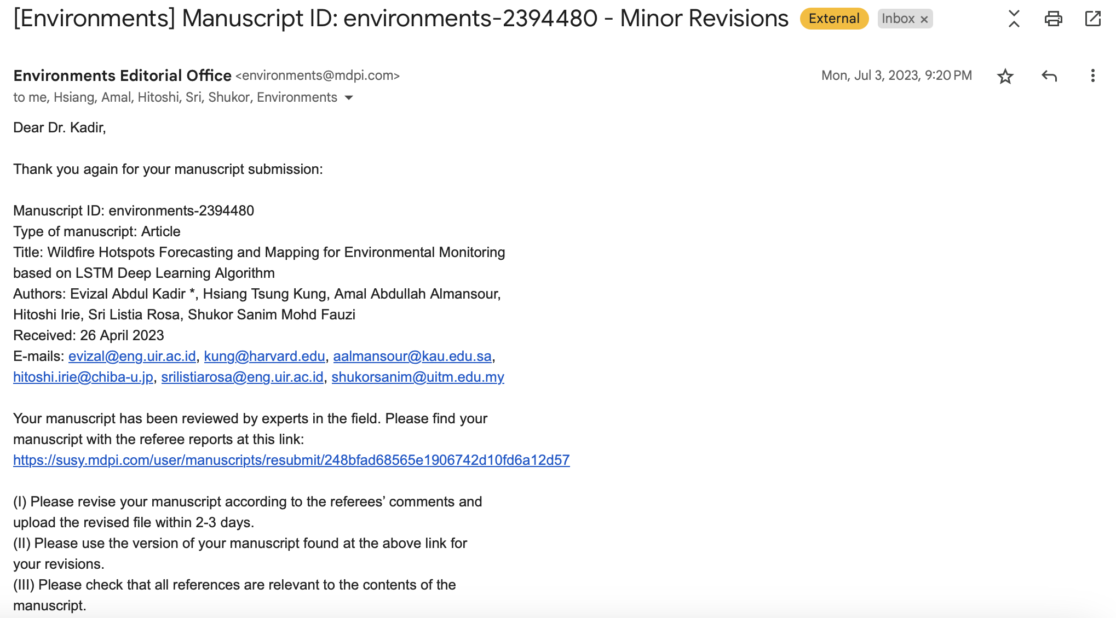

- Acceptance notification

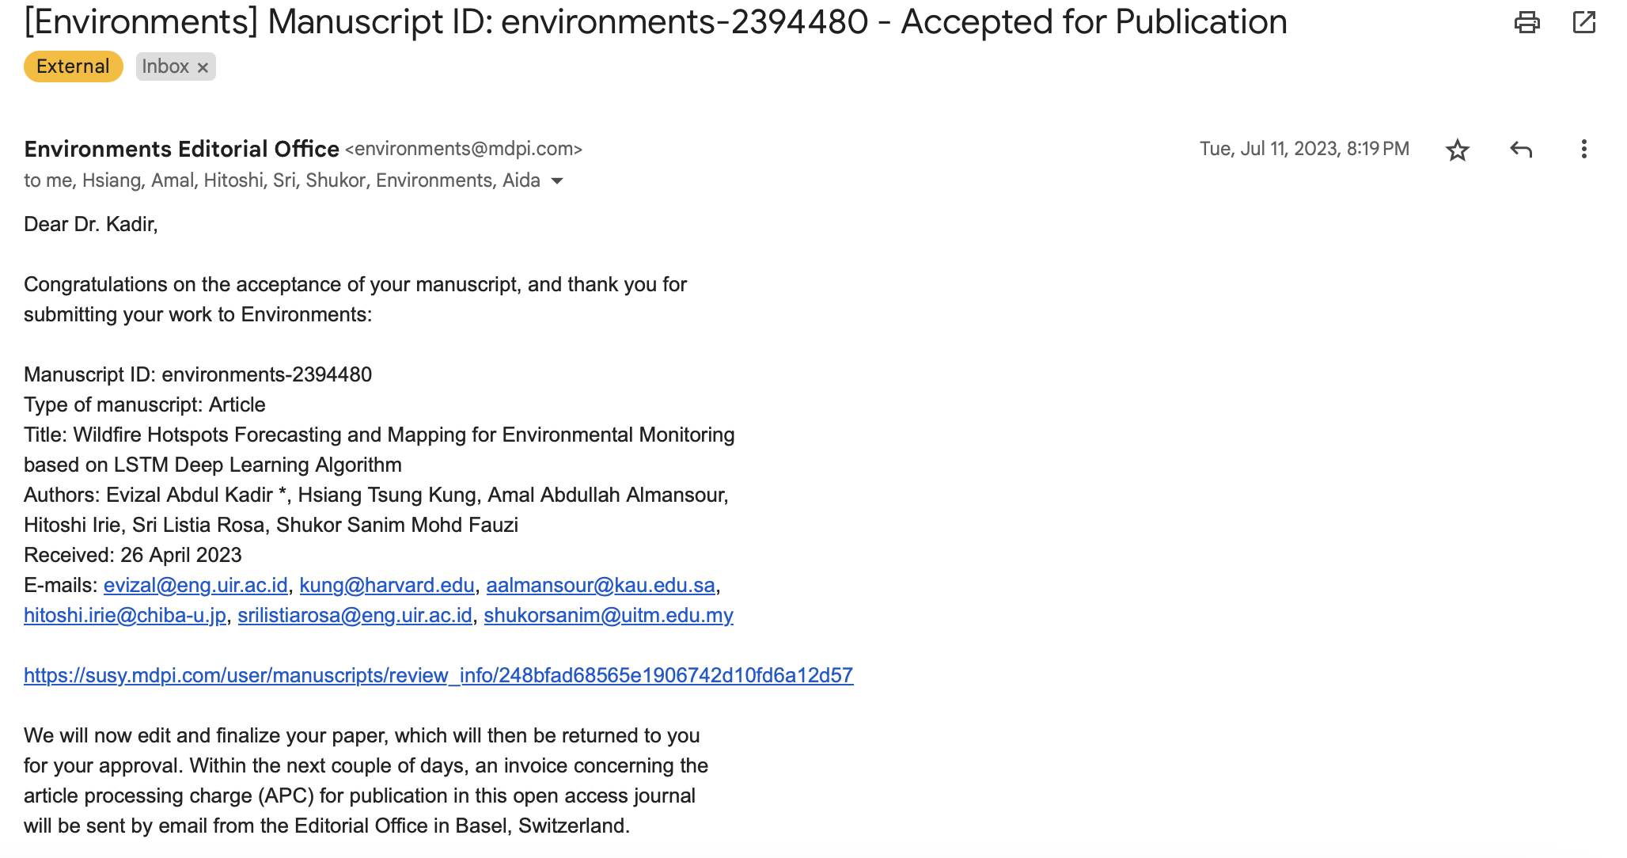

- Publish notification

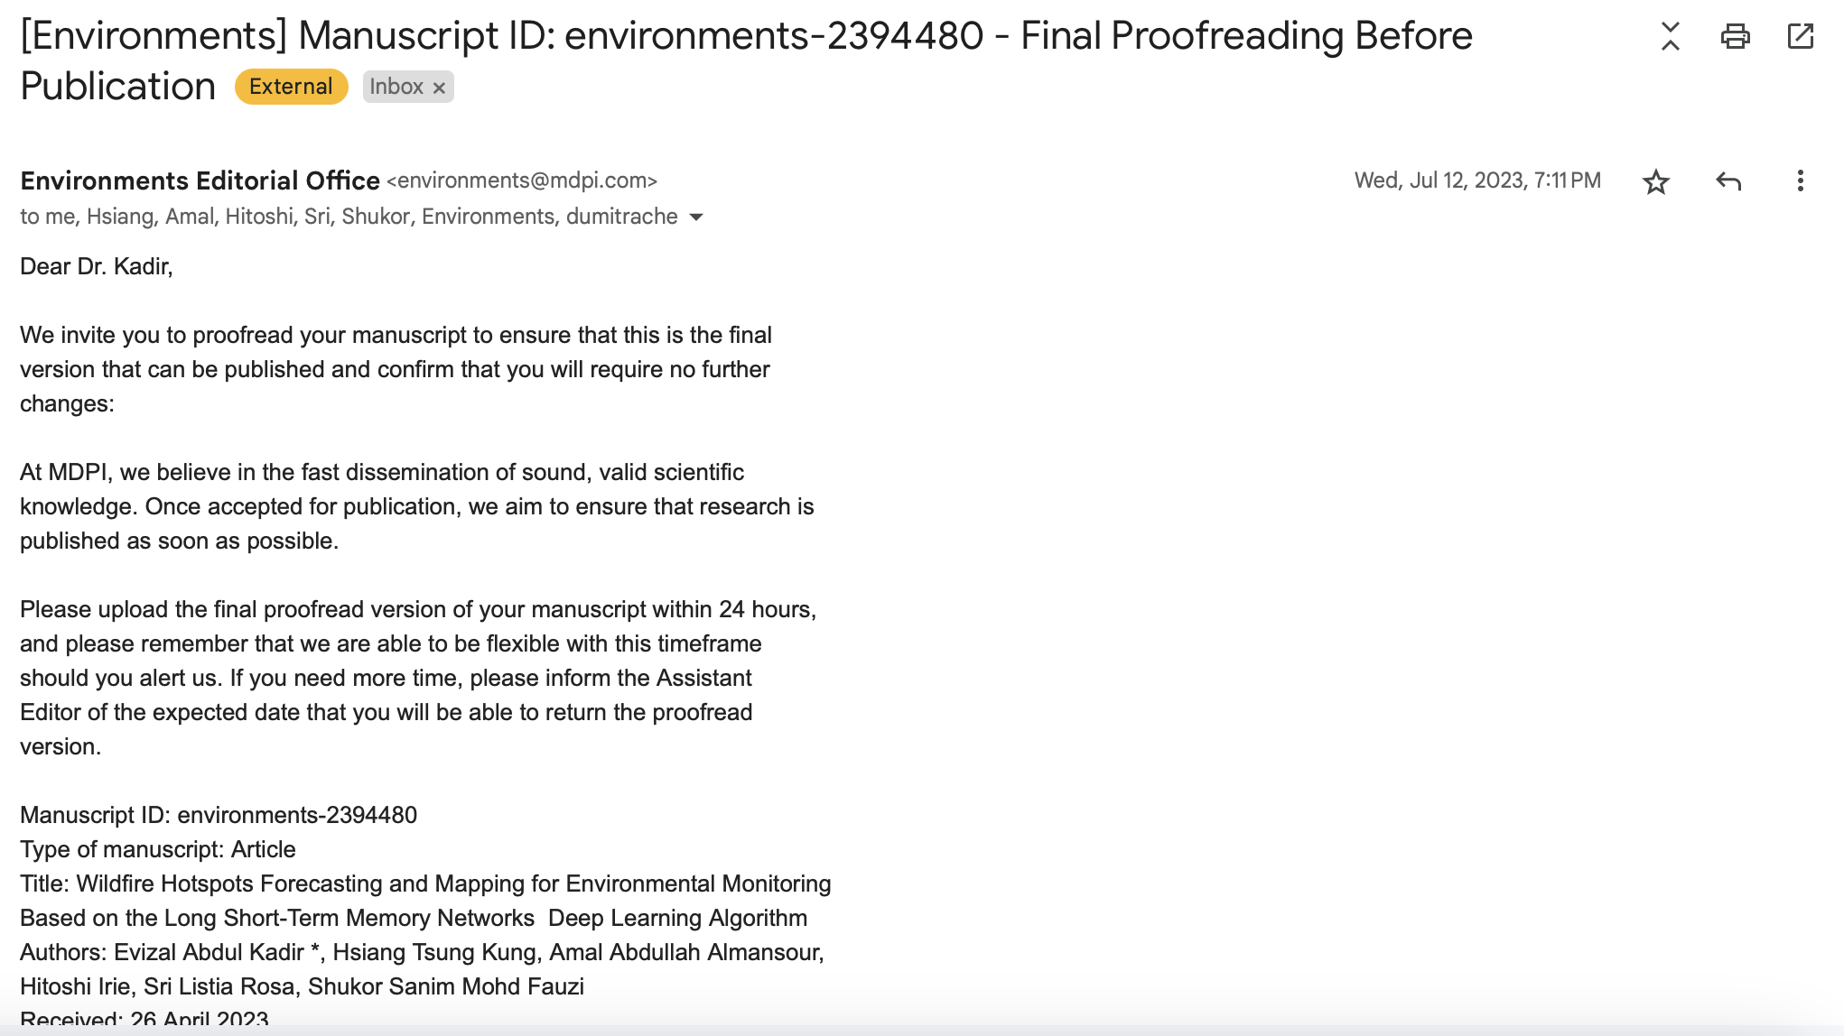

- Sri Listia Rosa, Evizal Abdul Kadir, Apri Siswanto, Mahmod Othmand, Hanita Daud Judul: “Identifying Water Pollution Sources Using Real-Time Monitoring and IoT” Dipublikasi pada Jurnal International Journal on Advanced Science, Engineering and Information Technology (IJASEIT)” Vol 12, No.1 Tahun 2022, Hal. 2122-2131. ISSN: 2088-5334. Online link: https://ijaseit.insightsociety.org/index.php/ijaseit/article/view/16367
Corresponded author: evizal@eng.uir.ac.id (Evizal Abdul Kadir)

- Submission

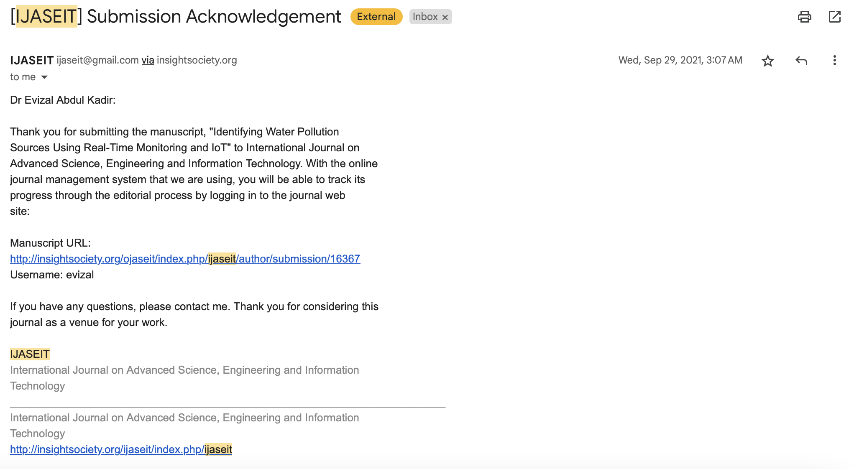

- Revision request

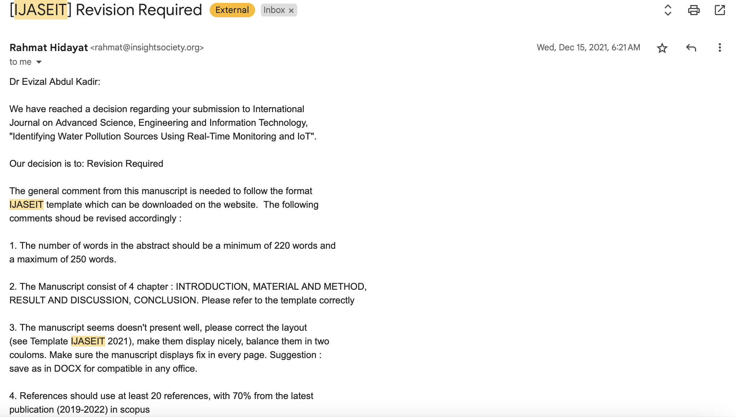

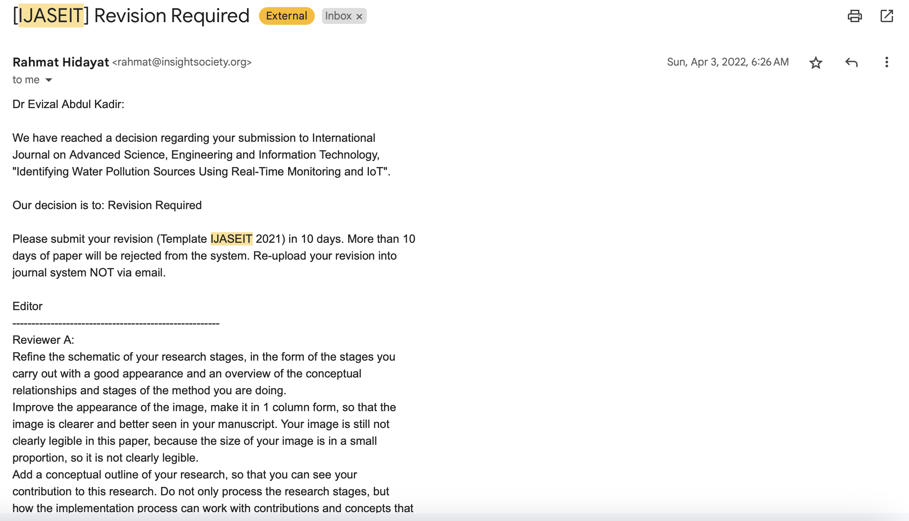

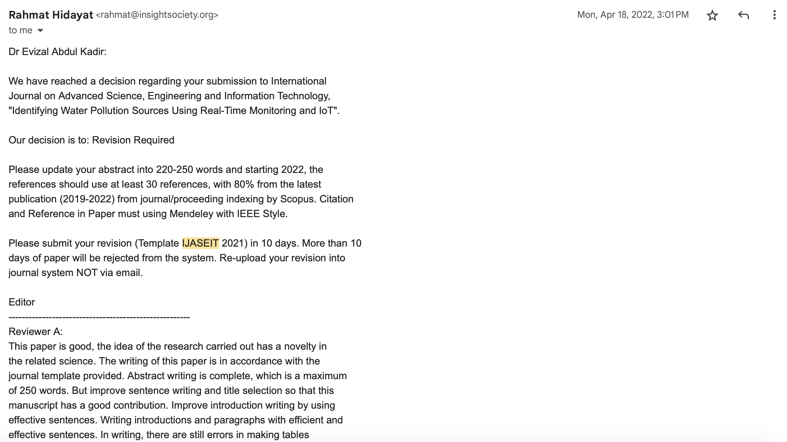

- Acceptance notification

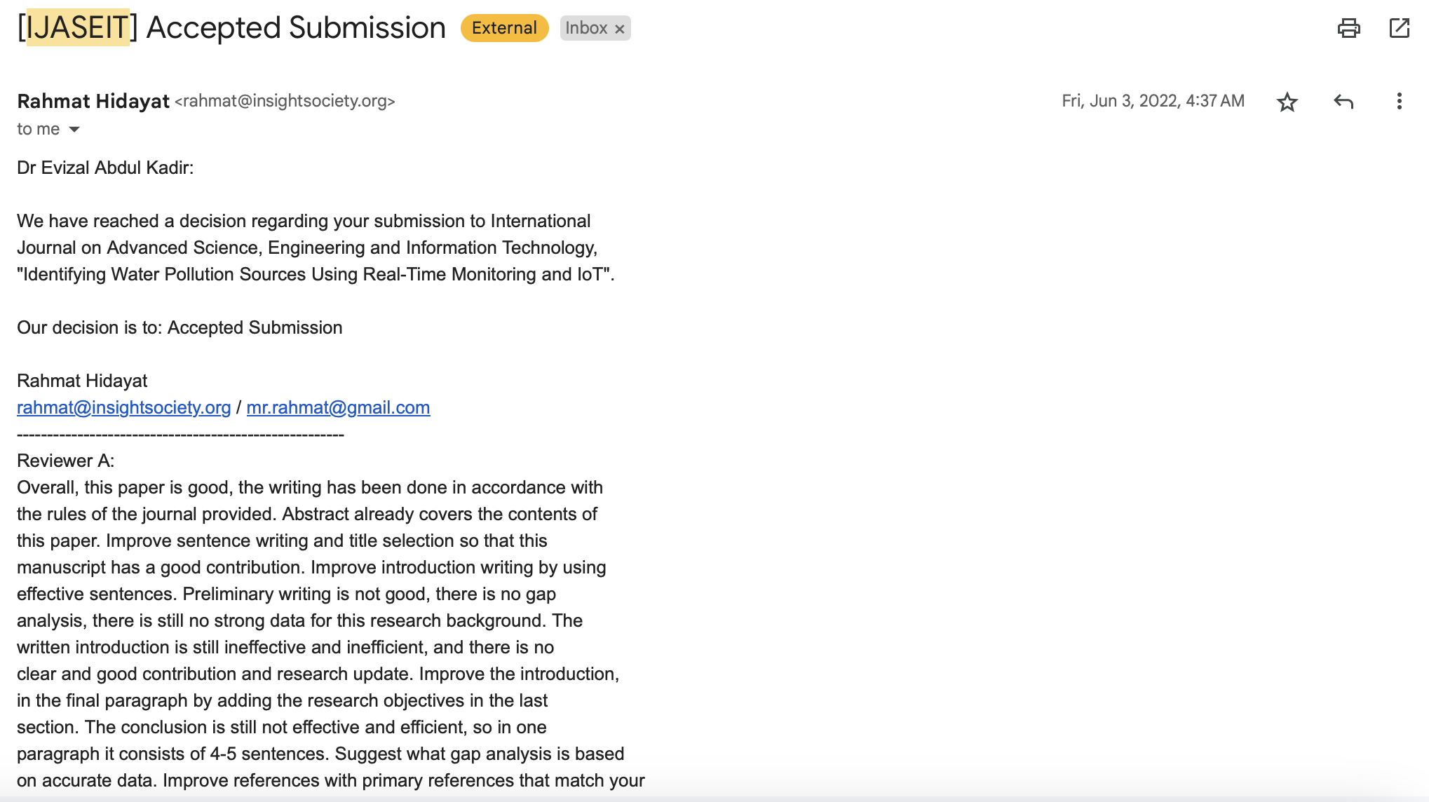

- Publish notification

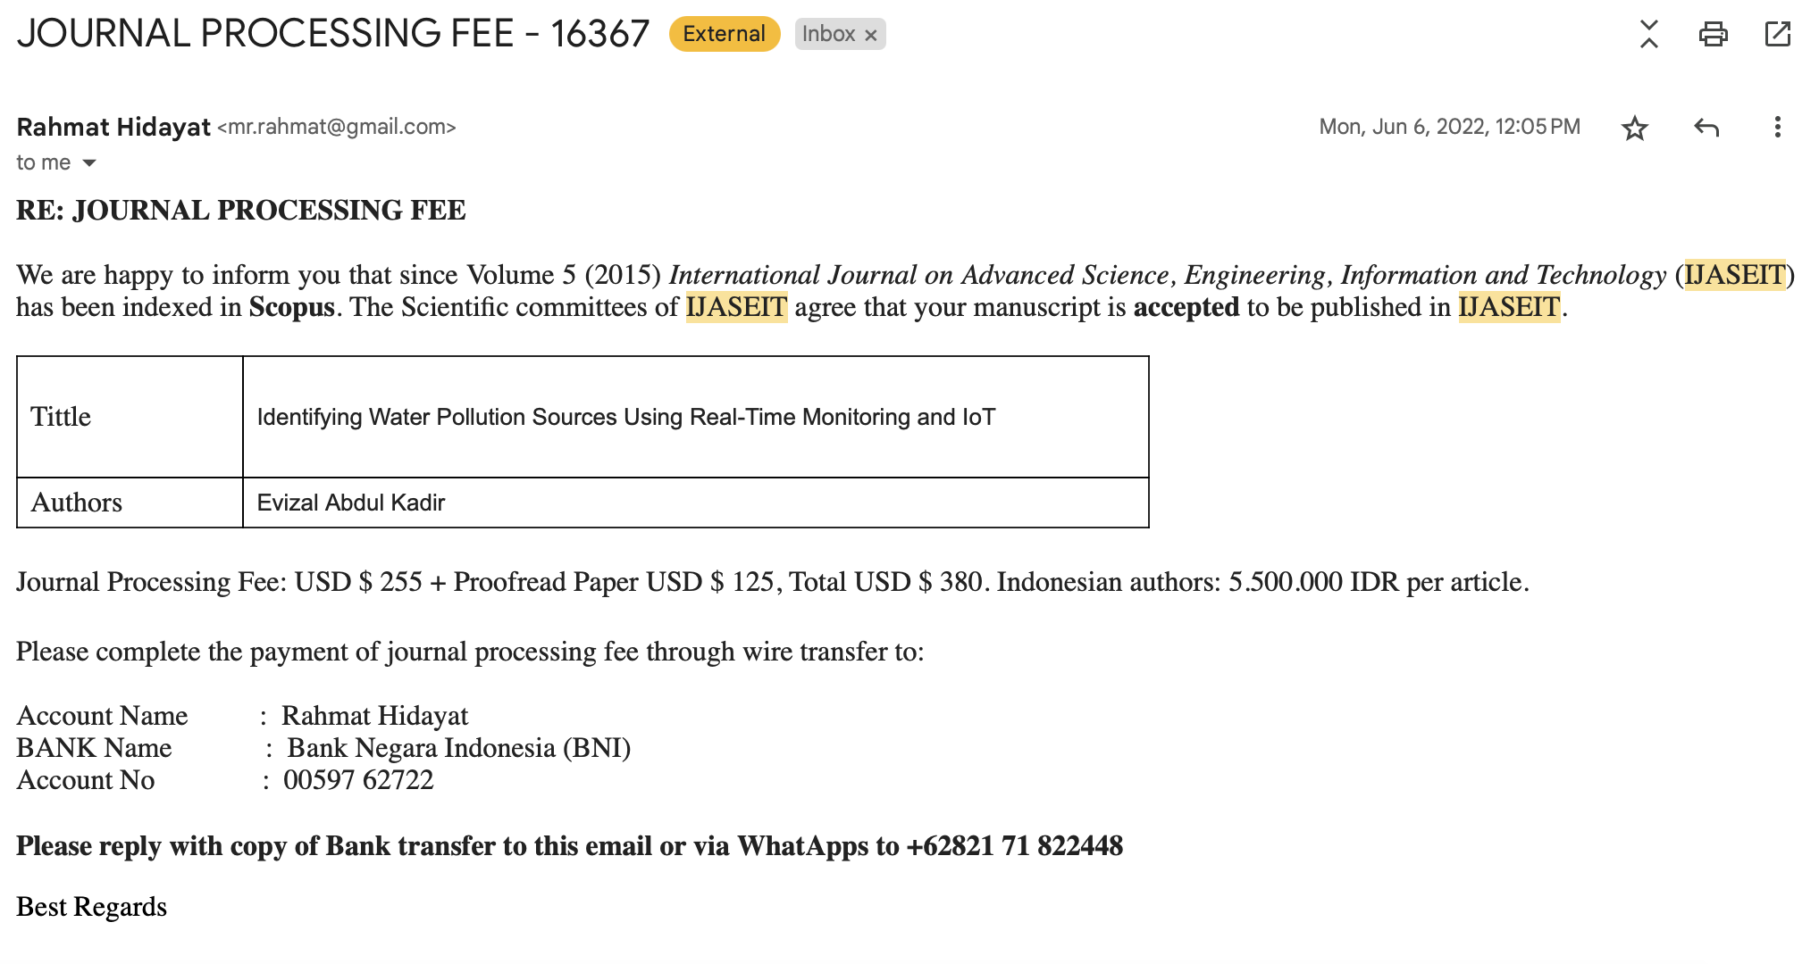

- Lenni Dianna Putri, Ermi Girsang, I Nyoman, Ehrich Lister, Hsiang Tsung Kung, Evizal Abdul Kadir, Sri Listia Rosa, Nama Jurnal: Public Health Implications for Effective Community Interventions Based on Hospital Patient Data Analysis Using Deep Learning Technology in Indonesia, MDPI Information, Vol: 15 No: 01, ISSN: 2078-2489. https://www.mdpi.com/2078-2489/15/1/41
Corresponded author: evizal@eng.uir.ac.id (Evizal Abdul Kadir)

- Submission

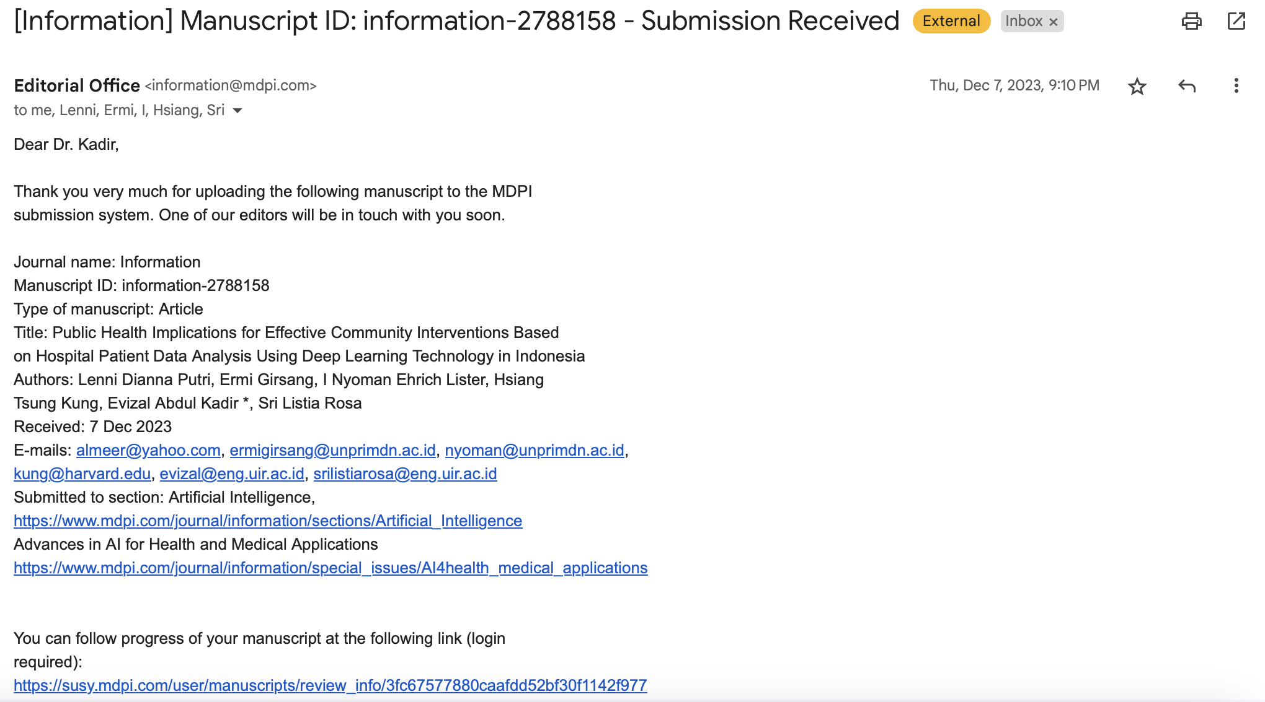

- Revision request

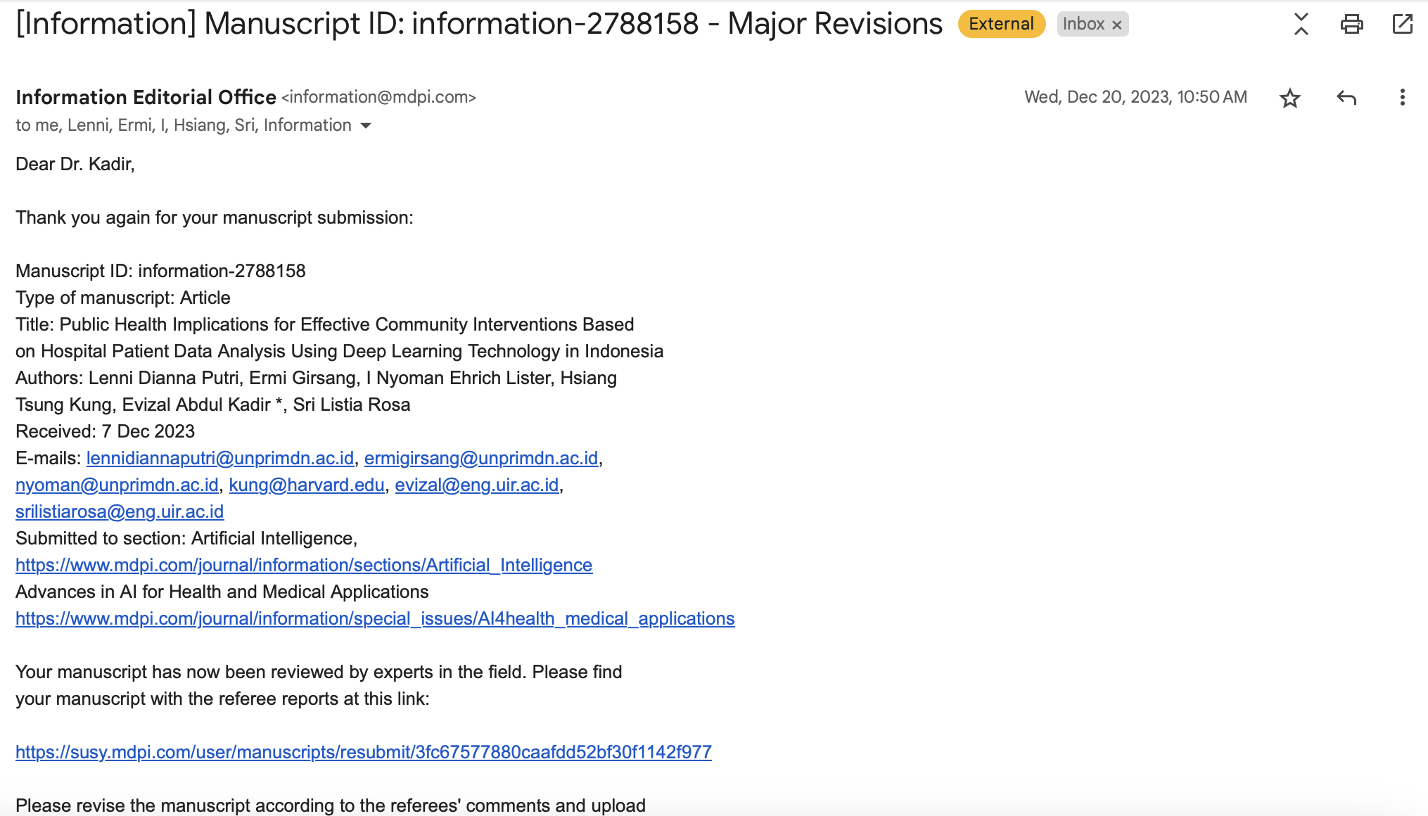

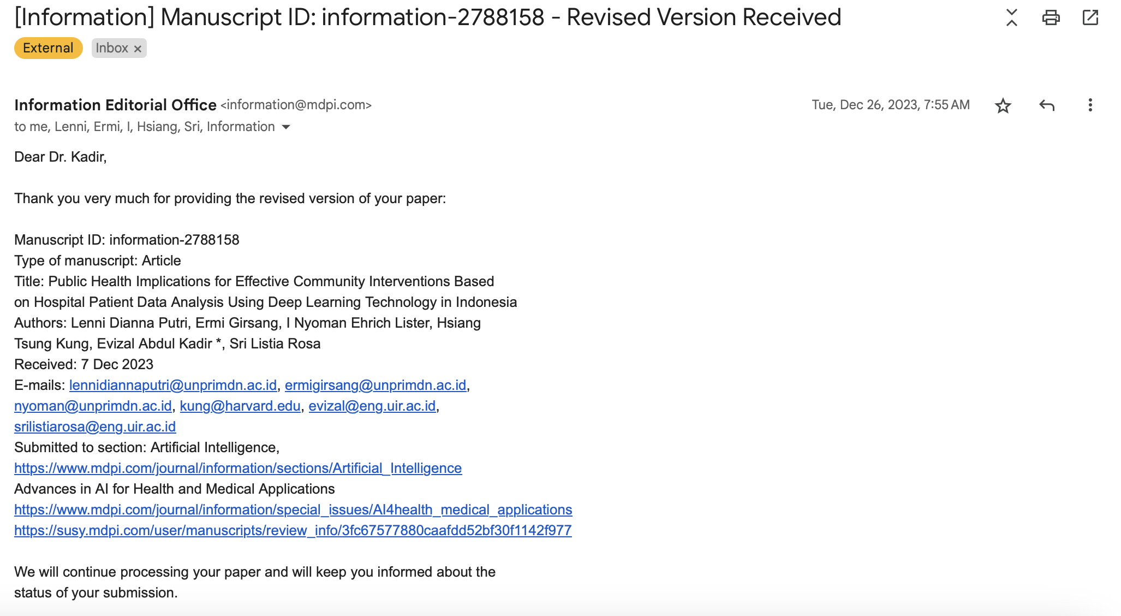

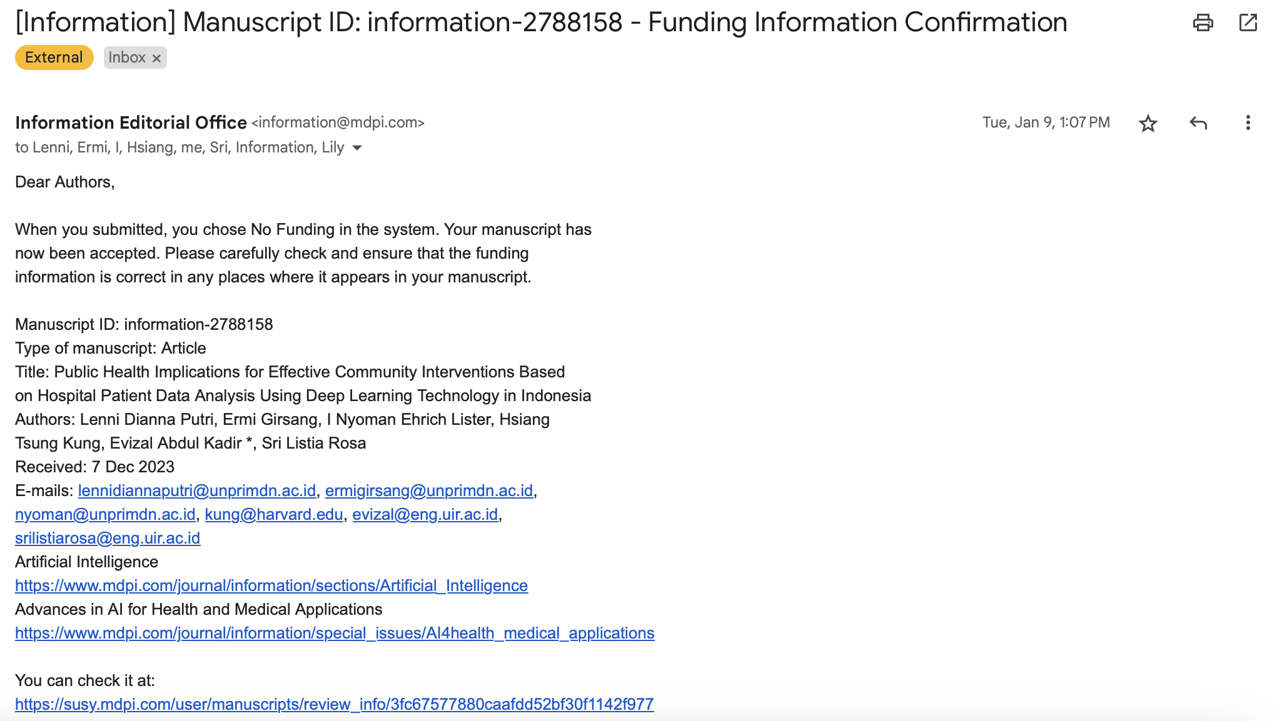

- Acceptance notification

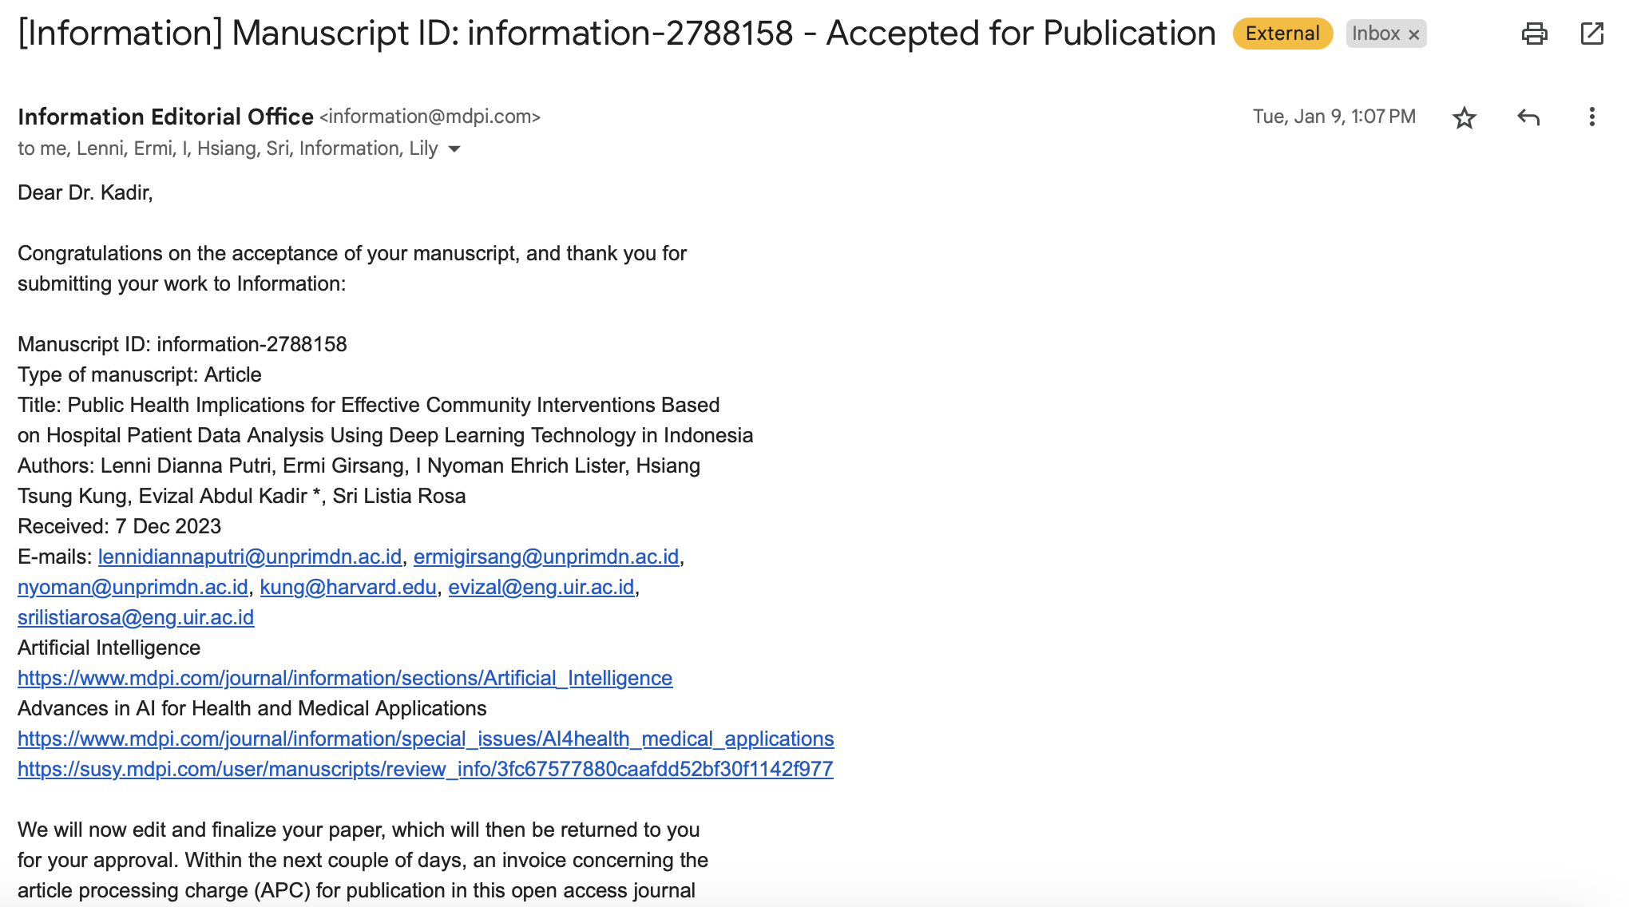

- Publish notification

